Software engineering for big data analaysis

CSA-1035

EXP NO: 29

Using Raptor – Draw and validate the flowchart to find odd series of the given number. The odd numbers are the numbers which are not divisible by 2. They are 1,3,5,7,9,11,13,15,17,19 etc.. Using Raptor – Draw and validate the flowchart to find even series of the given number

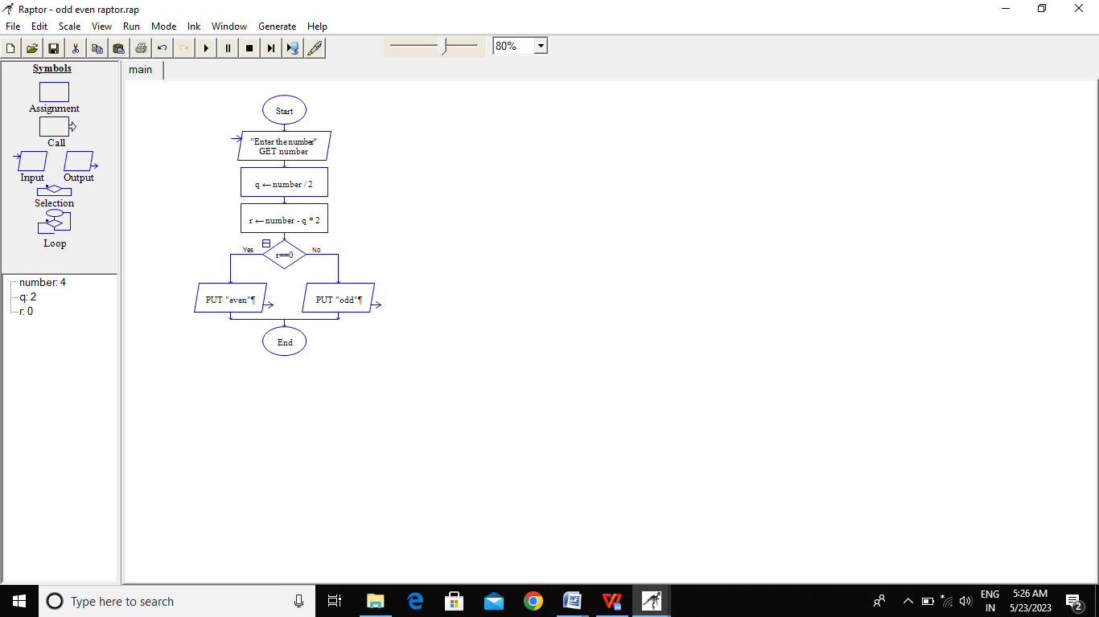

RESULT:-

BY Using Raptor for the odd and even series is verified successfully